System Requirements Specification (SRS)
Software Requirements Specification (SRS)
Project Name: RentFlow
Authors: Liron Avramov and Matan David
1. Introduction
1.1 Purpose
The purpose of this document is to define the system requirements for the smart system for handling renter and landlord communication, "RentFlow". This document serves as a reference for stakeholders, developers, and testers to ensure alignment on the system's goals and functionalities.
1.2 Scope
Rent Flow is a digital platform designed to simplify and centralize interactions between landlords and renters.
The system enables:
- Rent payments and automated reminders
- Electronic contract signing
- Maintenance request management
- Status transparency and notifications
The system aims to reduce paperwork, manual follow-ups, and unnecessary communication between
1.3 Definitions, Acronyms, and Abbreviations
- RentFlow: The smart system for handling renter and landlord communication.
- API: Application Programming Interface (used here for payments and technician recommendations).
- UI: User Interface.
1.4 References
- ISO 29148: Systems and software engineering – Life cycle processes – Requirements engineering
- OWASP Top 10: Security requirements for web applications
1.5 Overview
This document is organized into sections covering system overview, functional and non-functional requirements, database and interface requirements, design constraints, and appendices.

2. System Overview
RentFlow allows landlords and renters to manage their interactions with full clarity. Features include automated payment reminders, electronic contract signatures, and maintenance request tracking. The system emphasizes making life easier for both parties without them feeling bad about annoying each other.

3. References
- ISO 27001: Information security management
- PCI DSS: Payment Card Industry Data Security Standard (relevant for payment APIs)

4. System Context
4.1 System Context Diagram
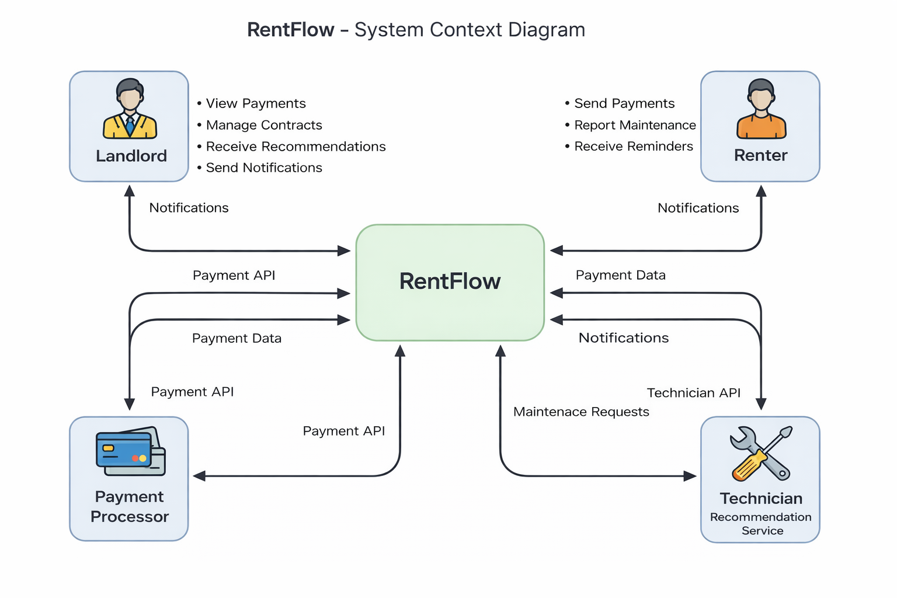
The System Context Diagram illustrates the interaction between the RentFlow system and its external actors:
- Landlords
- Renters
- External Payment Processors
- Technician Recommendation Services
The diagram highlights the main data flows such as payments, notifications, and maintenance requests.
4.2 External Interfaces
- Payment API: Processes payments for the landlord and generates receipts.
- Technician Web Service: Provides recommended technicians from the web based on breakdown reports.
5. Functional Requirements
5.1 By System Mode
- FR-001 The system shall support a Normal Mode for standard operations such as payments and contract management.
- FR-002 The system shall support a Maintenance Mode during system updates and downtime, during which users are notified.
5.2 By User Class
- FR-003 The system shall enable Landlords to manage contracts, electronic signatures, and view one or more properties.
- FR-004 The system shall enable Landlords to receive recommended technicians and automatically update the renter on arrival times.
- FR-005 The system shall allow Renters to update the landlord regarding breakdowns in the house or other requests.
- FR-006 The system shall allow Renters to view alerts for unpaid payments and the status of requests.
Renter
- FR-006 The system shall allow renters to submit maintenance requests.
- FR-007 The system shall allow renters to view unpaid payment alerts and request statuses.
5.3 By Features
- FR-008 The system shall automatically remind renters of unpaid rent payments.
- FR-009 The system shall facilitate electronic signatures for rental contracts.
- FR-010 The system shall display maintenance request status to both parties.
- FR-011 The system shall generate digital receipts via Payment API integration.
- FR-012 The system shall notify both parties upon changes in payment or maintenance status.
- FR-013 The system shall log critical actions such as payments, contract signatures, and status changes.

6. Non-Functional Requirements
6.1 Performance Requirements
- NFR-PERF-001 The system shall respond to 95% of user requests within 2 seconds under normal load.

6.2 Usability Requirements
- NFR-USE-001 The system shall provide an intuitive web-based user interface.
- NFR-USE-002 The system shall be accessible via desktop and mobile browsers.

6.3 Reliability Requirements
- NFR-REL-001 The system shall maintain 99.5% uptime excluding planned maintenance.
- NFR-REL-002 The system shall perform daily backups of critical system data.

6.4 Security Requirements
- NFR-SEC-001 The system shall enforce role-based access control (RBAC).
- NFR-SEC-002 The system shall encrypt sensitive data in transit and at rest.
- NFR-SEC-003 The system shall comply with PCI DSS requirements for payment handling.

6.5 Maintainability Requirements
- NFR-MNT-001 The system shall be modular and well-documented to support future enhancements.

6.6 Portability Requirements
- NFR-PORT-001 The system shall be deployable on standard cloud-based infrastructure.

7. Logical Database Requirements
7.1 Data Description
The system shall manage the following primary entities:
- User (Landlord, Renter)
- Property
- Contract
- Payment
- Maintenance Request
- Technician Recommendation

7.2 Data Access and Frequency
- Payment and maintenance data shall be accessed frequently and in real time.
- Contract data shall be accessed on demand.

7.3 Integrity Constraints
- Each entity shall have a unique identifier.
- Referential integrity shall be enforced between related entities.

7.4 Security Constraints
- Access to sensitive data shall be restricted based on user roles.
- All database access shall be logged.

7.5 Data Retention Requirements
- Contracts and payment records shall be retained for a minimum of seven (7) years.

8. Interface Requirements
8.1 User Interfaces
- Web-based responsive UI for landlords and renters.
- Notification interfaces for alerts and reminders.

8.2 Hardware Interfaces
- No special hardware interfaces are required.

8.3 Software Interfaces
- External Payment API
- Technician Recommendation Web Service

8.4 Communication Interfaces
- All communications shall use HTTPS.

9. Design Constraints
- The system shall comply with ISO 27001 and relevant security standards.
- The system shall rely on third-party APIs for payments and technician recommendations.

10. Other Requirements
No additional requirements are defined at this stage.

11. Appendices
A. Glossary
See Section 1.3.
B. Acronyms
- API – Application Programming Interface
- RBAC – Role-Based Access Control
C. Index
Not applicable.

D. Additional Material
System context diagrams and UI mockups may be added in future iterations.

